Workflow Functional Document

Application: | NGERP-CENTRA
WorkFlow: | Quote To Cash
WorkFlow Item Name: | COGS Adjustment Journal

Description
This workflow used to create the journal for adjust the cost of goods whenever goods purchasing into the HQoW and ROW systems with manual process.

Work Flow Process:
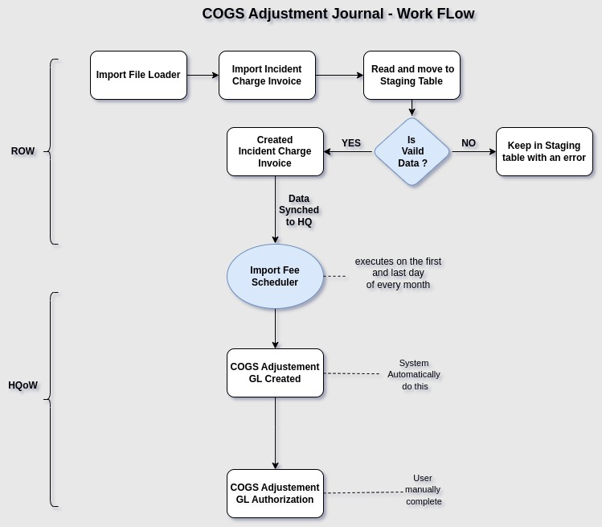

Business Rules:

- A COGS Adjustment Journal refers to an accounting entry made to adjust the Cost of Goods Sold (COGS) account. This adjustment is typically necessary when there are discrepancies between the recorded inventory cost and the actual inventory cost
- Inventory adjustments - such as shrinkage, spoilage, or errors in inventory counting.
- Price changes - if there are variances in the cost of purchasing inventory items
- The COGS Adjustment Journal ensures the accuracy of the COGS amount reported in financial statements, which is crucial for accurately reflecting gross profit and overall profitability.

